

This smart motion sensor, adopts super low power ZigBee wireless network design and automatic threshold adjustment technology to enhance the stability of the sensor, efficiently anti-false alarm. Automatic temperature compensation technology, can efficiently prevent sensors from the decrease in sensitivity resulted from the temperature variation. Products suitable for safety protection of residential, villas, factories, shopping malls, warehouses, office buildings, banks, computer rooms and other places.

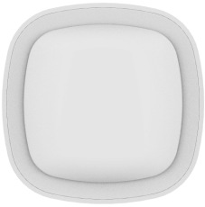

**Smart Motion Sensor**

***Premium Add-on device for your home***

***Features***

* **Standard ZigBee protocol;**
* **Low power consumption design, support battery lifespan up to 1.5 years;**
* **Support PET immunity function;**
* **Support online monitoring function;**
* **Low power alert and report function;**
* **Free tool installation, stick and play;**
* **Auto temperature compensation, greatly improve sensitivity;**
* **Battery polarity reverse protection, over current protect;**
* **Anti-dismantle alarm;**
* **Nicera Sensor;**
* **Ultra slim design, with appearance patent;**

Specification

* Model Number: HS1MS-TY
* Working Voltage:DC3V
* Battery Type: 1xCR123A battery
* Battery Life: 1.5 years
* Standby Current：<20uA
* Alarm Current: ≤36mA
* Detecting Angle: 90°
* Install Height：2.1m
* Detecting Distance：9~12m
* Networking Way: ZigBee 2.4GHz
* Wireless Distance: ≤100m (open environment)
* Anti-RF Interference：80MHz — 1GHz 10V/m
* Working Temperature: -10℃ ～ +50℃
* Working Humidity：≤95%RH
* Dimension: 65x65x28.5 mm
* Gross Weight: 67g